SAE Paper 2014-01-1052

**Design, Analysis, and Simulation of an Automotive Carbon Fiber Monocoque Chassis**

Jingsi Wu, Owusu Agyeman Badu, Yonchen Tai, Albert R. George

Cornell University

Copyright © 2013 Cornell University – Permission granted to SAE to publish in all forms

**Abstract**

While many composite monocoque and semi-monocoque chassis have been built there is very little open literature on how to design one. This paper considers a variety of issues related to composite monocoque design of an automotive chassis with particular emphasis on designing a Formula SAE or other race car monocoque chassis. The main deformation modes and loads considered are longitudinal torsion, local bending around mounting points, and vertical bending. The paper first considers the design of elements of an isotropic material monocoque that has satisfactory torsional, hardpoint, and vertical bending stiffness. The isotropic analysis is used to gain insight and acquire knowledge about the behavior of shells and monocoque structures when subjected to a vehicle’s applied loads. The isotropic modeling is then used to set initial design targets for a full anisotropic composite analysis. The flexibility in composite layout and core design coupled with the superior material properties of carbon fiber composites is used to design and move toward an optimized monocoque composite design and layup to obtain satisfactory torsional, hardpoint and bending stiffnesses with minimal weight. Finally, some fatigue analysis considerations are outlined with emphasis on the endurance limit of the monocoque for a specific life span. The methods presented in this paper should be helpful in designing a monocoque structure chassis for FSAE race car or other applications.

**Introduction**

This paper presents some rationale and techniques for the design of a composite monocoque chassis for a formula-type car. The techniques are presented based on the design of an FSAE monocoque. While the particular design is not representative of all composite chassis, the techniques and results should be of interest in most composite chassis situations.

Although carbon composite structures have great advantages in stiffness to weight they are not easy to design and build. Thus, before beginning design of a composite chassis, some key questions need to be raised. Why do we need the composite monocoque chassis? What does the composite monocoque do? How does the composite monocoque help us design a low weight, sturdy chassis? In addition, for an FSAE competition, how well will this help us win the competition?

The main purposes of the monocoque are, first, to provide rigid, safe, and sufficiently strong supports and protection to the driver, engine, and all components on a car at minimum weight. Second, the monocoque should enable the suspension to exhibit excellent handling. There are two approaches to designing a chassis to help handling, one is to make the monocoque sufficiently strong but allow it to be somewhat soft, and design the whole chassis based on the predicted chassis deflections under various driving loads. This approach generally only works for cars with minimal or even no suspension systems, such as Go-Karts. However, the softer the chassis is, the bigger the deviations of the structural deflections get, and thus, the suspension design turns to be very difficult due to various combinations of tire camber, loading, and steer angle changes induced by varying local and overall chassis deflections. It is also very difficult to damp motions of a flexible chassis. The other approach is to design the chassis as rigid as needed to be able to design the suspension based on an essentially infinitely stiff monocoque. This is very effective for cars that rely on their suspension system for handling, and have a wide range of suspension setups. Since the suspension system has a crucial effect on the car’s handling, it is usual to attempt to make the monocoque adequately stiff enough to be considered effectively infinitely stiff. [1]

Vehicle Loading

The monocoque being stiff for suspension performance means it is capable of absorbing all static and dynamic loads with deflections that are small compared to those occurring in the suspension. The main deformation/structural criteria for an automotive chassis are: [1]

1. Longitudinal Torsion
2. Local Bending around suspension points
3. Vertical Bending
4. Lateral Bending
5. Horizontal Lozenging
6. Fatigue

In this paper we primarily discuss numbers 1, 2, 3 and 6 of these issues. (4 and 5 are usually not important for any reasonably rigid race car.) Also, we note that certain parts of the chassis associated with driver crash safety are often designed with strength as well as stiffness considerations. Thus for those sections the questions are how to minimize weight while maintaining sufficient strength and stiffness and how to use the stiffness of these areas to enhance overall chassis stiffness.

*Longitudinal Torsion*



Figure 1: Longitudinal Torsion Deformation Mode

Torsion loads result from applied loads acting on opposed corners of the car. The monocoque can be thought of as a torsion spring connecting the two ends where the suspension loads act. Torsional loading and the accompanying deformation of the monocoque and suspension parts can affect the handling and performance of the car. Torsional stiffness is generally agreed to be a primary determinant of tunable chassis performance for a FSAE and most race cars as the total cornering traction and the cars dynamic stability are functions of relative front versus rear lateral weight transfer. [1].The resistance to torsional deformation is often quoted as stiffness in Newton-meter per degree (foot-pounds per degree in US Customary units).

Historically, chassis design began with considerations of strength and safety and then progressed to stiffness and in particular, longitudinal torsional stiffness. Very early mentions of the need for torsional stiffness can be found in the 1962 book of Costin and Phipps [2] for example. Later more analytical discussions of criteria for chassis stiffness can be found in papers by Riley and George [1] and in Deakin, et al. [3]

*Local Bending Around Suspension Points*

Localized bending around suspension mounting points is a result of suspension system loads. The local stiffness around the suspension mounting points has a large influence on camber change. If the suspension mounting points deflect, the attributes of the suspension change. This results in changes in camber angle, etc. and loss of overall chassis torsional stiffness. Other causes of suspension behavior changes can be from suspension component deflections and suspension joint slop. These are quite small on most purpose-built race cars [4] but should be accounted for when significant.

*Vertical Bending*



Figure 2: Vertical Bending Deformation Mode

The weight of the driver and components mounted to the monocoque, such as the engine and other parts, are carried in bending through the car chassis. Vertical accelerations can raise the magnitude of these forces. [1]

*Fatigue*

Components are often mounted on the monocoque by the use of inserts or “hardpoints” molded or bonded into the cellular sandwich structure. These joints are potential locations of fatigue deformation due to cyclic loading from components such as the engine and suspension mounted on the monocoque. [5]

It is generally thought that if the torsional, hardpoint and vertical bending stiffnesses are satisfactory then the structure will generally be satisfactory if its fatigue properties are also satisfactory. Fatigue is treated briefly at the end of this paper.

Chassis Stiffness Targets

With the loading conditions determined as discussed above, it should then be possible to design the structure to be strong enough not to fail under the global and local loads acting on it for the different load cases. Just as important, however for a racing car, is the stiffness of the entire chassis structure as it affects the proper vehicle dynamics and handling. Exactly how stiff to make the structure is difficult to determine theoretically, and historically was determined empirically based on experience gathered mostly from driver feedback. Analytically the problem is to examine how much of the overall vehicle compliance occurs in the structure compared to the deflections in the spring and tire. Obviously, for an infinitely rigid chassis the car will respond only to the spring, damper and anti-roll bar changes. Some stiffness approaching the infinite case, compared to suspension torsional rates, should provide a stable platform for the suspension to do its job as explained in Reference [1]. For the present paper we use an example target of about 5000 Nm/deg, based on the expected suspension rates of the vehicle.

After identifying the critical loads and setting strength and stiffness targets, the monocoque can now be designed. The approach we use is to first consider the design of a monocoque constructed of an isotropic material to guide the design of the anisotropic case. The observations and conclusions drawn from the isotropic material case provide initial insights that help in the design of the carbon fiber monocoque. A fundamental goal of chassis design is adequate strength which can be relatively easily checked for any given design. However, usually design for stiffness is the more difficult issue. The focus of this paper is primarily on stiffness and secondarily on strength.

Isotropic Analysis

The principal criteria in the design of a monocoque chassis are:

1. Torsional Stiffness
2. Hardpoint Stiffness
3. Bending Stiffness

*Simplified Torsional Stiffness Analysis*

There are very few open literature papers found on monocoque chassis design. A good overview of the problems in designing and assembling a full monocoque from individual shells was published by Weidner, et al. in 2002.[6] In the present paper we similarly start with some very simplified analyses to guide the later, more complex design of a monocoque including the best use of core and number and kind of plies and orientations on various parts of the monocoque.

A monocoque chassis can be modeled the most simply as a cylinder with a cutout as shown in figure 3. The cutout roughly mimics the cockpit of a racing car. (For a road car, analogous geometric simplifications could be made.)

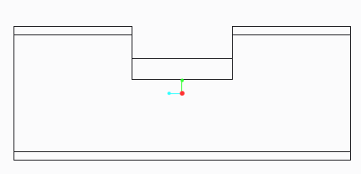

Figure 3: Cylinder with a cutout

Intuition and quick analysis in ANSYS Workbench reveals that the cut-out portion is the weakest part of the cylinder. If the cylinder is cantilevered with a torque applied at the other end as shown in Figure 4, the front end of the cylinder deflects very little compared to the cut-out section. This is because the front end is a closed section tube, which performs very well in torsion. The cut-out section, however, is open and therefore deflects greatly. The cut-out section does not twist, but rather it skews. From the top view, the section deflects from a rectangle into a parallelogram (Figure 5). This means that when a torque is applied to the monocoque, the primary mode of deflection around the cockpit is not twisting but rather for the nose to deflect to one side or the other. The cockpit therefore undergoes a horizontal lozenging deformation mode.

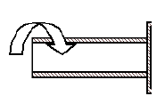

Figure 4: Cantilevered cylinder with applied torque

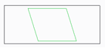

Figure 5: Top view of cylinder with skewed cut-out section after applied torque

Since the overall stiffness of the monocoque chassis is largely dependent on the stiffness of its weakest section, it is important to understand the mechanics of the cut-out section of the cylinder. A mathematical model to examine the torsional stiffness problem is developed as shown in Figure 6:

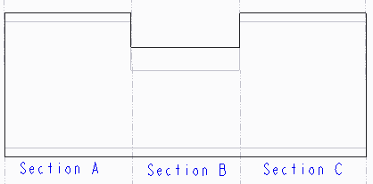

Figure 6: Cylinder divided into 3 sections of interest

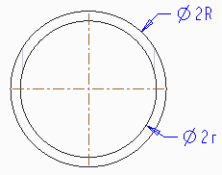

Figure 7: Cross-section of section A

The torsional stiffness of section A can be derived simply as:

|  |  |
| --- | --- |
| $T_{A}$*= $\frac{GJ_{A}}{L_{A}}∅$*  *where $J_{A}=\frac{π(R^{4}-r^{4})}{2}$*  G – Shear modulus $J_{A}$ – Polar moment of inertia of cylinder section A $L_{A}$ – Length of section A | (1) |

The torsional stiffness of section A can be written as:

|  |  |
| --- | --- |
| $$K_{T}^{A}=\frac{GJ_{A}}{L_{A}}$$ | (2) |

The torsional stiffness of section B requires more subtle analysis. A cross-section of the cut-out section shows in a U-shape. Since this is not a circular cross-section, the twist induced by the externally applied torque is transformed into a horizontal lozenging deformation mode. [7] A quick analysis done in ANSYS Workbench reveals this is true.

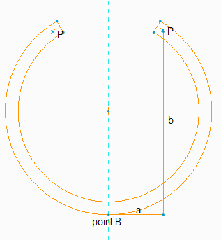

Figure 8: Cross-section of section B

From Figure 8, it is apparent that, we are twisting[1] about point B. We can see that there are 2 moment arms from the force (P) to the point B that cause the lozenging.

|  |  |
| --- | --- |
| $$T_{B}+M_{B}=\frac{GJ_{B}}{L_{B}}∅-EIK$$ $T_{B}$ =P $∙$ b will result in torsion $M_{B}$ =P $∙$ a will result in bending | (3) |

To simplify the problem, we assume unconstrained lozenging and assume that the effect of bending due to “P $∙$ a” is so small, it can be neglected. [7] Another way to think about this is that bending is along the strong axis. Therefore, it does not control the design and as such, we are designing to satisfy torsion.

|  |  |
| --- | --- |
| $T_{B}=\frac{GJ_{B}}{L_{B}}∅$*where $J_{B}=\frac{L_{B}t^{3}}{3}$*    G – Shear modulus $J_{B}$ – Polar moment of inertia of cylinder section B $L_{B}$ – Length of section B  t – Thickness of cylinder | (4) |

The torsional stiffness of section B will be given as:

|  |  |
| --- | --- |
| $$K_{T}^{B}=\frac{GJ_{B}}{L_{B}}$$ | (5) |

Now that we understand the behavior of a cylinder (with a cut-out) under torsion, we can deduce the combined torsional stiffness. The stiffness of the entire system can be found from

|  |  |
| --- | --- |
| $$\frac{1}{K_{T}^{Total}}=\frac{1}{K_{T}^{A}}+\frac{1}{K_{T}^{B}}+\frac{1}{K_{T}^{C}}$$ | (6) |

Note that sections A and C have the same polar moment of inertia values. The relation between T and $∅$ for both sections can be written as

|  |  |
| --- | --- |
| $$T=\frac{π\left(R^{4}-r^{4}\right)G}{2L_{A}}∅$$ $$K_{T}^{A}=K_{T}^{C}=\frac{π\left(R^{4}-r^{4}\right)G}{2L_{A}}$$ | (7) |

To find the stiffness of section B, we need to write P in terms of T. If we analyze the internal forces that result from the externally applied torque T, we find that, P is T/2R.

|  |  |
| --- | --- |
| $$P∙b=\frac{L{(R-r)}^{3}G}{3L_{B}}∅$$ $$\frac{T}{2R}∙b=\frac{L_{B}{(R-r)}^{3}G}{3L_{B}}∅$$ $$T=\frac{2L_{B}{(R-r)}^{3}GR}{3L_{B}b}∅$$ $$K_{T}^{B}=\frac{2R{(R-r)}^{3}G}{3b}$$ | (8) |

Next, we validate the approximate analytical model with a simulation in ANSYS Workbench. The results are shown in Table 1.

Table 1: Analytical versus ANSYS $K_{T}^{Total}$ values in SI units

|  |  |  |
| --- | --- | --- |
| **Input Parameters** | **Output Parameter** | |
| T = 50Nm  G = 80GPa  R = 0.10m  r = 0.090m  b = 0.19m $L_{A}$ = ${ L}_{B}$ = 0.13m | **Analytical Approximation (MNm/deg)** | **ANSYS Workbench (MNm/deg)** |
| $K_{T}^{Total}$ = 0.028 | $K_{T}^{Total}$ = 0.031 |

The ANSYS result is within 11% of the analytical result. The reason for the difference between the two results is that, in our analytical solution, we assume unconstrained lozenging. Unconstrained lozenging means that, the cut-out section (section B) warps in isolation (In other words, sections A and C are assumed to be absent).

The main task in the design of the monocoque chassis for torsional stiffness is then to find a weight-efficient way to stiffen the cockpit region. The expression for $K_{T}^{B}$ gives us an idea of how to vary the various parameters to increase the stiffness of the cockpit region.

*Cockpit Stiffening Techniques*

One common method of stiffening the opening is to use a lip or beam around the opening. We tried various other stiffening techniques in ANSYS Workbench and compared the specific stiffness (stiffness to weight ratio) of the resulting designs. We included some unconventional stiffening techniques in these simulations.

Table 2: Legend for the stiffening techniques

|  |  |
| --- | --- |
| **Representation** | **Stiffening Technique** |
| 1 | Monocoque with cut-out |
| 2 | Monocoque with cut-out and 0.013m stiffener plate on the bottom of cut-out region |
| 3 | Monocoque with cut-out and 0.019m stiffener plate on the bottom of cut-out region |
| 4 | Monocoque with cut-out and 0.025m stiffener plate on the bottom of cut-out region |
| 5 | Monocoque with elliptical cut-out (Minor axis is along the length of the monocoque) |
| 6 | Monocoque with very small cut-out |
| 7 | Monocoque with no cut-out |

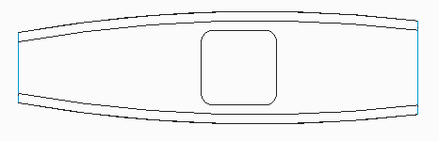

Figure 9: Monocoque with cut-out



Figure 10: Monocoque with cut-out and 0.013 m stiffener plate on the bottom of cut-out region



Figure 11: Monocoque with cut-out and 0.019 m stiffener plate on the bottom of cut-out region



Figure 12: Monocoque with cut-out and 0.025 m stiffener plate on the bottom of cut-out region

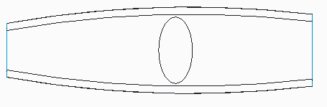

Figure 13: Monocoque with elliptical cut-out (Minor axis is along the length of the monocoque)

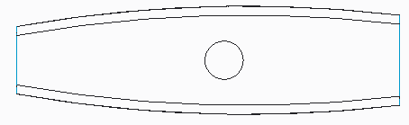

Figure 14: Monocoque with very small cut-out

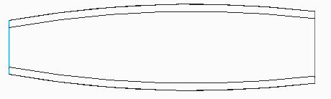

Figure 15: Monocoque with no cut-out

The basis of the stiffening techniques is to vary the parameters in the $K_{T}^{B}$ expression $(K_{T}^{B}=\frac{2R{\left(R-r\right)}^{3}G}{3b})$ and subsequently determine the percentage increase in the torsional stiffness of the overall monocoque. The technique denoted as 1 is the monocoque in its unstiffened form. Techniques 2, 3 and 4 are based on increasing “R-r” or the thickness of the bottom of the cut-out section. In techniques 5and 6, the effect of constrained lozenging on the stiffness of the cut-out section is investigated. Our $K_{T}^{B}$ expression, as mentioned earlier, is based on the assumption that lozenging is unconstrained. In actuality, lozenging is constrained and techniques 5and 6 introduce different forms of constraining lozenging and determining the increase in overall monocoque torsional stiffness.

Technique 7 is a closed section tube with no cut-out and therefore, performs very well in torsion. Technique 7 gives the target torsional stiffness value. Based on our $K_{T}^{B}$ expression, of course there are other stiffening techniques such as increasing the outer diameter of the monocoque or changing the monocoque material from steel to another material of higher shear modulus that were not considered in our analysis.

The results from the stiffening analysis are presented in Figures 18 and 19.

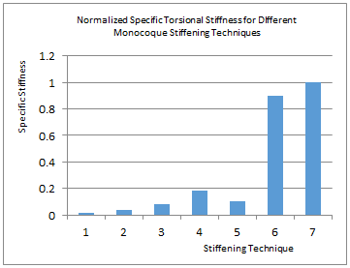

Figure 16: Normalized specific torsional stiffness of different stiffening techniques

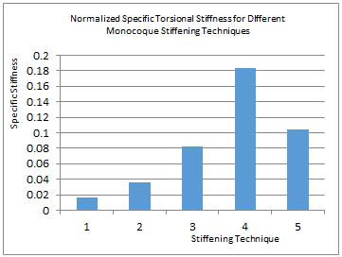

Figure 17: Normalized specific torsional stiffness of different stiffening techniques

To efficiently show the results and to make them general to any vehicle we normalized the values by the length of the monocoque. The final point on the graph represents the specific stiffness of a unit length monocoque without a cut-out (target specific stiffness). The second graph captures the first five stiffening techniques in detail. From the graphs, we can deduce that, increasing the thickness of the cut-out region increases the specific torsional stiffness of the monocoque. This means, the increase in stiffness due to the increase in thickness outweighs the added weight due to the increase in thickness. A monocoque with a small cut-out (1/5 times the size of the cut-out of technique 1) has a specific stiffness value equal to 90% of the target specific stiffness value.

These graphs should provide a general idea of what a monocoque designer should expect, in terms of stiffness versus weight savings, when implementing any of the example stiffening techniques.

*Stiffness Analysis of Hardpoint Locations*

Points where the suspension system, engine, etc. are attached to the frame or monocoque (hardpoints) need to have optimum local stiffness and strength. In some chassis designs such as tube frames or semi-monocoques the suspension and other loads can be taken at bulkheads, longerons, internal beams, or where other local internal structure can stiffen the attachments. This is a very desirable situation where practical. Even for a full monocoque chassis some loads can be taken at front or rear bulkheads or at engine mounting or roll bar locations.

However, in most Formula cars the desire for a narrow chassis plus the need for room for the driver means that some suspension attachments will likely be made to the monocoque itself. These may be either local inserts added into or built into the core or local geometry modifications such as tapering the core to zero thickness and locally adding extra composite layers. As mentioned earlier, local deflection of suspension mounting points may result in changes in camber, steer angle, etc. and loss of overall torsional stiffness.

As an example we analyze loads from lower suspension links (which carry the heaviest loads for most suspension systems) that are mounted on a transition from the sides of the monocoque to the bottom of the monocoque. This transition can either be a bevel/chamfer or a radius (See figure 18). The attachment points experience extremely high loads on the order of 20 kN for a 2G bump for a Cornell’s 2011 FSAE car for example. Ignoring the angles that the suspension loads make with the monocoque at the points of attachment, we simplify the above problem to a point load normal to a plate (chamfer or bevel transition) or shell (radius transition).

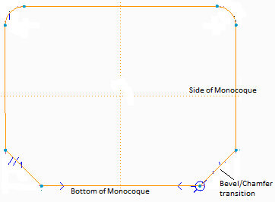

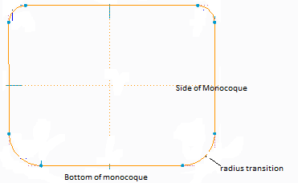

Figure 18: Front view of monocoque showing chamfer and radius transitions.

*Plate Analysis*

First we analyze an attachment on a local flat section (chamfer). Since the thickness of a plate is small in comparison with other dimensions, certain simplifying assumptions can be introduced which reduce plate problems to two-dimensional rather than three-dimensional analysis. The well-known Kirchhoff hypothesis (Classical Plate Theory) is an example. It assumes that lines normal to a plate's middle surface before deformation remain normal after deformation. [8]

Another less restrictive assumption asserts that displacements vary linearly over the plate thickness. All of these assumptions are kinematic in nature; they impose no restrictions on the order of magnitude of the strains in the plane of the plate or on the order of magnitude of the displacements. [9]

When a thin flexible plate is subjected to transverse loads, it displaces normal to its middle plane and forms a curved surface. If the transverse displacements are small in comparison with the thickness of the plate, the strains in the middle surface are usually small and negligible in comparison with those developed in the extreme fibers. [9] If the plate undergoes large transverse displacements, however, significant strains may be developed in the deformed middle plane.Mathematical descriptions of these phenomena involve highly nonlinear partial differential equations for the transverse displacements. Few exact solutions to these equations are available in the literature, [9] and, in the case of plates with irregular shapes and boundary conditions, exact solutions are practically difficult. Because of this difficulty in obtaining exact solutions, numerical methods such as the finite element method are often employed to obtain quantitative solutions to these problems.

We therefore ran numerous simulations in ANSYS Workbench to get a general sense of the behavior of plates subjected to point loads. We varied the plate parameters in a controlled way and performed analysis of variance in order to be able to make useful and accurate generalizations about the out-of-plane behavior of plates. To assist in the design of hardpoints on zero curvature chamfer panels, graphs are given to aid the initial decision making process.

To be able to use the graphs, it is important to understand the model set-up and how the controlling parameters were varied.

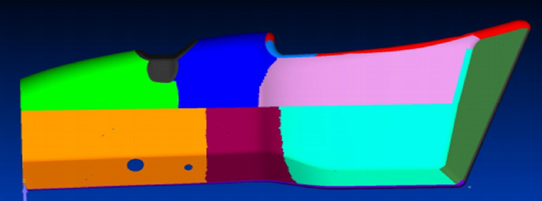

Figure 19: Chamfer Transition – Load applications show by blue dots

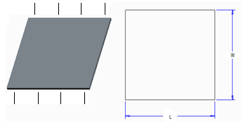

Figure 20: Plate Model for Chamfer Transition

We modeled the suspension load on a locally flat chamfer (See figure 20) by setting up a plate, fixed on two sides and free on the other two sides, with a point load acting on the center of the plate. The fixed sides are assumed to approximate the greatly increased stiffness at the fold angles at the edge of the chamfer. The parameter ‘W’ represents the width of the chamfer. ‘L’ is the length of the fixed edge of the chamfer along the monocoque. We kept the distance ‘L’ constant and increased ‘W’ for a particular plate thickness. The results are presented in Figures 21 through 24.

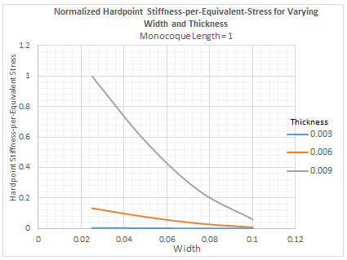

Figure 21: Normalized Chamfer transition stiffness-to-equivalent-stress for varying chamfer width and thickness

The plots are stiffness-per-equivalent stress (stiffness/von Mises stress) for different chamfer width and thickness. To make the results general to any monocoque design, we normalized all the values with the length L of the monocoque. Since plates typically have a thickness-to-width ratio of approximately 0.1 or less, the final point on the graph for the “0.009 thickness plot” represents the maximum stiffness-per-equivalent-stress value for a plate. To use the plots, cross reference the chamfer width with the chamfer thickness and read off the stiffness-per-equivalent-stress. For example if we desire a stiffness-per-equivalent-stress that is 80% of the maximum value, we have the option of choosing a chamfer with a thickness that is 0.009 times the length of the monocoque and a width that is 0.036 times the length of the monocoque. The individual “thickness plots” are shown in Figures 23 through 25.

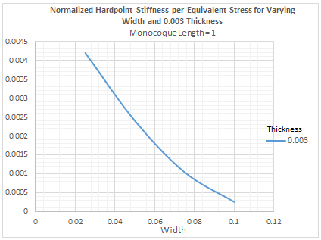

Figure 22: Normalized Chamfer transition stiffness-to-equivalent-stress for varying chamfer width and 0.003 thickness

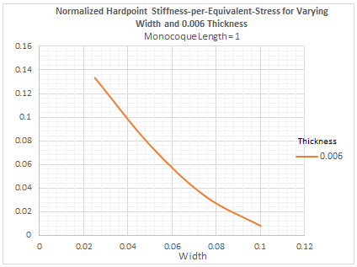

Figure 23: Normalized Chamfer transition stiffness-to-equivalent-stress for varying chamfer width and 0.006 thicknesses

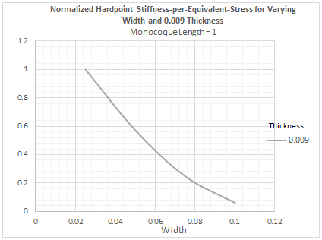

Figure 24: Normalized Chamfer transition stiffness-to-equivalent-stress for varying chamfer width and 0.009 thicknesses

In general, for a particular thickness, the hardpoint stiffness-per-equivalent stress decreases as the width of the chamfer increases. To put it simply, as the width of the chamfer increases, the equivalent stress increases and the stiffness also decreases significantly. Therefore, the stiffness-per-stress decreases. For a particular chamfer thickness, the designer should opt for smaller chamfer widths. How small the width of the chamfer should be will depend on the suspension attachment sizes and options available to the designer.

We present an example on how to read figure 24: A chamfer transition from side-to-bottom of monocoque with thickness, 0.009 times the length of monocoque and width, 0.08 times the length of monocoque will have a stiffness-per-stress value that is 20% of the maximum attainable value for a chamfer.

*Shell Analysis*

Next we analyze a suspension hardpoint location on a curved surface. In this case shell analysis is used to design the hardpoint. As with plates, it is difficult to obtain exact solutions for shells under point loads and thus we have to resort to numerical methods such as the finite element method to obtain quantitative solutions to these problems.

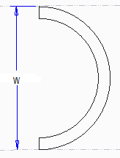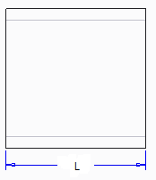

Figure 25: Model for Radius Transition

As shown in Figure 25, the set-up for the shell analysis is similar to that for the plate analysis. The only difference is we fix both ‘L’ and ‘W’ and vary the radius of curvature. The graphs are read the same way as the plate analysis graphs.

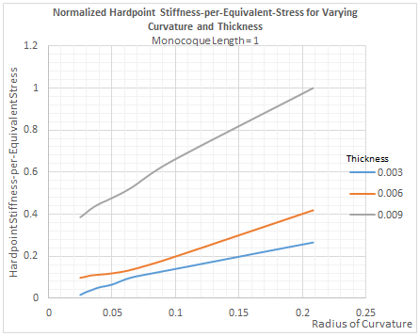

Figure 26: Normalized Radius transition stiffness-to-equivalent-stress for varying radius of curvature and thickness

One would expect that, an increase in the radius of curvature (decrease in curvature) would result in a less stiff hardpoint. Though this is true, we realize from Figure 26 that, as we increase the radius of curvature (decrease curvature), the stress developed at the point of application of the load decreases significantly. Therefore, the stiffness-per-stress increases with increase in radius of curvature. Figure 27 better describes what is explained above.

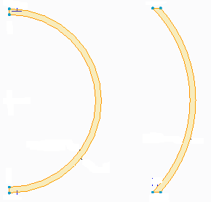

Larger Curvature Smaller Curvature

Higher Stiffness Lower Stiffness

Higher Local Stress Lower Local Stress

Figure 27: Shells of different curvature under point load

To put it simply, as curvature increases, the stiffness increases but the stress also increases significantly because there is less “surface area” exposed per point load. By that, the stiffness-per-stress decreases. Thus, to keep stresses within some bound, we cannot infinitely increase curvature in order to attain high stiffness.

An example on how to read figure 27: A radius transition from side-to-bottom of a monocoque chassis with thickness, 0.009 times the length of monocoque and radius of curvature, 0.150 times the length of monocoque will have a stiffness-per-stress value, which is 82% of the maximum value for a shell.

The decision to use a chamfer or to use a radius transition between the side and bottom of the monocoque is up to the designer. In the context of carbon fiber monocoque design, it is easier to jig and attach suspension components to a chamfer. The chamfer allows almost straight pieces of carbon and core of the sandwich structure to be laid down and results in much simpler pattern making while the radius transition is normally difficult to lay up because it requires the cutting of more complex carbon and core shapes. It is also difficult to get the core to bend around the radius. The radius transition, on the other hand, may make it easier, to route lines, hoses, and electrical wires. For the same weight, the radius transition also has a higher stiffness-per-stress value.

*Vertical bending stiffness analysis*

Load and Resistance Factor Design (LRFD) is used to design the bottom or other panel of the monocoque in bending. (LRFD is also sometimes called Limit State Design, LSD) LRFD is a reliability theory and limit-state based design technique that accounts for variability/uncertainty in loads and resistances compared to the Allowable Stress Design (ASD). Basically, it requires the probabilistic, factored maximum loads on the structure to be well within the elastic zone and that the structure meets desired criteria after repeated factored normal loads.

We make the following simplifications in our analysis:

1. All curvature effects of the panel of the monocoque are negligible.
2. The panel can be approximated by a simply-supported beam.

As an example, the significant loads on the bottom of the monocoque are the weight of the driver, the weight of the engine and the pedal bay load.

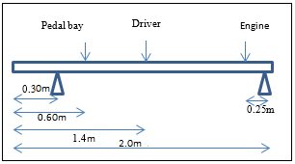

Figure 28: Bottom of the Monocoque under bending loads

For the sample case example studied we used:

3g bump, 2g braking

Loads: (1) Driver weight: 760 N

(2) Engine weight: 620 N

(3) Pedal bay load: 890 N

$M_{max}≤∅_{b}SF_{y}$ (9)

Where, $M_{max}$ is the maximum factored bending moment

$∅_{b}$ is the flexural resistance factor = 0.90

$S$ is the section modulus of the beam

$F_{y}$ is the yield strength of the material (Steel)

The load combination is:

$1.20DL+1.60LL$ (10)

Where, $DL$ is dead load and $LL$ is live load.

Even though the driver and engine weights are dead loads, in a bump/brake they have to be treated as live loads.

The worst case is 3g bump and $M_{max}=2370 Nm$

For $F_{y}$ of 250 MPa, $S$ can be solved for as ${11x10}^{-6}m^{3}$.

For a monocoque of isotropic material with a solid rectangular bottom of width 0.45 m, the minimum thickness of the bottom to avoid yield should be 0.012 m.

In general, if the design satisfies bending, it should satisfy shear. Now that the bottom of the monocoque of isotropic material has been designed against yield in bending and shear, we have to check deflection.

In LRFD, it is important to note that loads for deflection are unfactored. This means the load combination is DL + LL without associated load multipliers or factors.

The resultant live load (6810 N in a 3g bump) acts 0.70 m from the left support. Note that, the resultant is off-center.

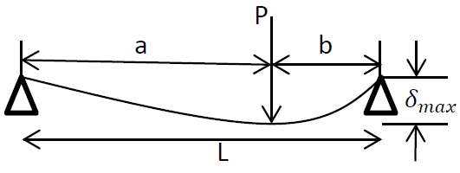

Figure 29: Deflection of beam with off-center load

The maximum deflection can be calculated as:

$δ_{max}=\frac{Pb{(l^{2}-b^{2})}^{3/2}}{9\sqrt{3}EIL}=0.048 m$ (11)

$P$ = 6810 N

$b$ = 1.1 m

$L$ = 1.7 m

$E$ = 200 GPa

$I$ = $6.8x{10}^{-8}m^{4}$

This result is for the deflection of a rectangular solid beam. Depending on the vertical stiffness requirement of the designer, the geometry of the bottom can be altered to improve the area moment of inertia ($I$) and subsequently decrease the deflection. A material of a higher Young’s Modulus will also decrease the deflection.

ANISOTROPIC ANALYSIS

From the isotropic analysis, we have the general behavior of monocoques in torsion, under point loads and in bending. We also have charts to initially size our monocoque components. The overall cross section sizes of the monocoque to start with are left to the designer based on the overall goals. We can now proceed to the anisotropic analysis of the monocoque. It is a good practice in anisotropic analysis to simplify the geometry and initially consider simple loading conditions.

Once the monocoque is broken down to simpler sections, common behaviors can be determined for each section. Whether it is under bending, torsion, or mixed loading condition, general methodologies can be developed to optimize each case. This section will explain how to break down complex monocoque geometry and optimize each section, under that section’s constraints, in order to check for adequate strength and obtain the best overall torsional, local and bending stiffness.

It is also important to mention that for the examples given the particular material analyzed is a sandwich structure with T300 weaves carbon fiber and 5250 aluminum core. The material properties for our examples are listed in Table 3.

Table 3: Material properties for T300 weave and 5250 aluminum core

E1 = Longitudinal Modulus, E2 = transverse Modulus, G12 = Shear Modulus, v12 = Poisson’s Ratio, Slp = Longitudinal strength tension, Slm = Longitudinal strength compression, Stp = Horizontal strength tension, Stm = Horizontal strength compression, and Slt = Shear strength

|  |  |  |
| --- | --- | --- |
|  | **T300 Weave** | **5250 Core** |
| **E1 (GPa)** | 58.6 | 0.0069 |
| **E2 (GPa)** | 58.6 | 0.0069 |
| **G12 (GPa)** | 3.86 | 0.0069 |
| **v12** | 0.0600 | 0.300 |
| **Slp (GPa)** | 0.703 | ~~ |
| **Slm (GPa)** | 6.21 | ~~ |
| **Stp (GPa)** | 0.703 | ~~ |
| **Stm (GPa)** | 6.21 | ~~ |
| **Slt (GPa)** | 0.0780 | ~~ |

*Analysis by Section*

The best way to decompose a complex geometry is to decompose it into smaller and simpler regions and then analyzing each based on the behavior previously learned from the isotropic analysis. The idea of this process is to take the behaviors and trends developed from the isotropic model and apply them to individual sections of the monocoque with an anisotropic customization of the laminate property, so the overall property can be moved toward an optimum, based on the sum of the improvements made to the individual sections.

The first step to decompose the model is identifying the critical regions based on the particular requirements of the design. For design for an FSAE competition, contest rules and regulations were given in the FSAE 2013 rule book.[10] For an FSAE chassis the Main Hoop bracing support, Front Hoop bracing, Bulkhead, Front Head Supporting structure, and Side Impact structures must be constructed in such way that it would be equivalent or better than specified steel structures they replace. Because of the rule requirements, these sections must be separately analyzed and are the ones most likely to have a more specific laminate design.

The next important section is the lip area around the driver cut out. The isotropic analysis in previous section reveals that these regions are under the largest stress, and therefore they will have their specific geometric reinforcements and laminate designs, most likely more plies, to reduce stress build-up.

After that, sections are separated based on suspension mounts and mass attachments. Areas with applied loads and significant attached masses are experiencing a mixed loading condition, where both bending and torsional stress are present. These panels must be optimized for mixed loading condition in order to satisfy both stresses. On the other hand, the areas without insert mounts and significant attached weight may be under approximately pure torsion and their laminate should be optimized for torsion only.

The last area of interest is the rear region where the engine mounts. Because of the cyclic loading, fatigue analysis must be considered to make sure no fatigue failure will occur during the lifetime of the vehicle as will be explained in a later section of the paper. Based on the criteria from above, the 2013 FSAE monocoque from Cornell University was decomposed into following sections (Figure 30).

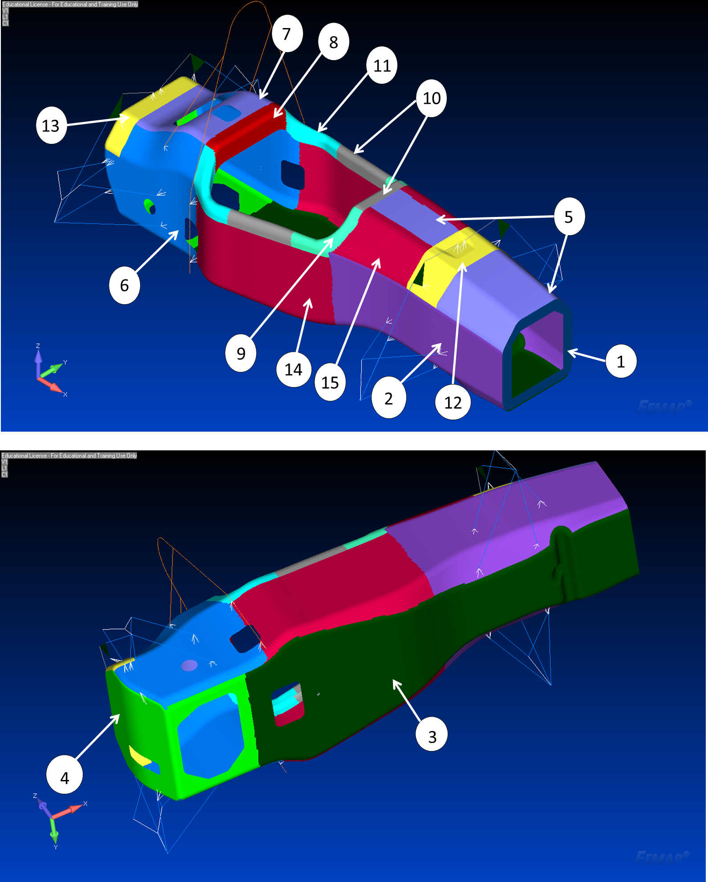

|  |  |  |  |
| --- | --- | --- | --- |
| **No.** | **Panel Name** | **No.** | **Panel Name** |
| **1** | Bulkhead | **9** | Front Lip |
| **2** | Front Support | **10** | Middle Lip |
| **3** | Bottom | **11** | Back Lip |
| **4** | Back | **12** | Front Damper/Rocker |
| **5** | Front Hoop Bracing | **13** | Back Damper/Rocker |
| **6** | Back Support | **14** | Side Impact |
| **7** | Back Hoop Bracing | **15** | Impact Bracing |
| **8** | Shoulder Belt |  |  |

Figure 30: The composite monocoque of 2013 race car is decomposed into 15 sections to reduce the complexity of the analysis.

Once the regions are identified, each one must be analyzed to determine the critical loading condition. This could be either bending dominant, torsion dominant, or a mix of both. A table as illustrated in Table 4 can be created for each area, so they can later be optimized based on their critical load cases.

Table 4: Critical load cases for following panels as example

|  |  |  |  |  |
| --- | --- | --- | --- | --- |
| **Panel #** | **Panel Name** | **Bending** | **Torsion** | **Mixed** |
| **1** | Bulkhead |  | X |  |
| **2** | Front Support |  | X |  |
| **3** | Bottom | X |  |  |

*Torsional Optimization*

To optimize a panel in torsion, one must understand the physical behavior of the monocoque panel under torsional load. If most sections of the monocoque can be treated as an open ended cylinder, a torsional force applied to the main axis of the cylinder is similar to a shear force applied to a rectangular surface that comes from the same cylinder when cut open. Figure 31 is a simple diagram that illustrates this concept.

|  |  |
| --- | --- |
|  |  |
| ***(a)*** | ***(b)*** |

Figure 31: a) a cylinder under torsion, b) the same cylinder is cut open, and the same torsion is similar to a shear on the flat sheet

The same idea is confirmed by the analytical equation of torsional stiffness, equation 12. [11]

|  |  |
| --- | --- |
| $$T=\frac{JGφ}{L}=K_{T}φ$$ J= Polar moment of inertia  G= Material Shear modulus of elasticity  L= Characteristic length of the cross section $$K_{T}=Torsional stiffness$$ $$φ=angle of twist$$ $$T=Applied torque$$ | (12) |

It can be deduced from the equation that the torsional stiffness of the geometry varies directly with the shear modulus, G. This means that the shear property of the material can directly impact the overall torsional stiffness. The equation also reveals that the polar moment of inertia, J also directly affects the torsional stiffness. Since it is a variable that relates to the geometry of the object, for a hollow cylinder the best option to increase the J value is to move material away from the center, which means increase the cylinder diameter. However, in this situation, the dimensions are constrained. Therefore, the best option is to increase the wall thickness as much as practical, given other design constraints. Compared to other variables, G and J are easier to adjust using the optimization method explained later. They will turn out to be the biggest factors impacting the overall torsional stiffness.

*Ply-Order & Ply-Orientation*

To vary the shear property of a composite laminate, one must begin with the force-deformation relationships for a symmetric laminate under in-plane loads. The governing equation is a part of the Classic Laminate Theory as shown below in equations 13 and 14.[12]

|  |  |
| --- | --- |
|  | (13) |
| $$A_{ij}=\sum_{k=1}^{N}{{\left({\overline{Q}}_{ij}\right)}_{k}(z_{k}-z_{k-1})}$$ | (14) |
| $A_{ij}$ = Components of the Laminate extensional stiffness matrix  N= In-plane forces  εo= Mid-plane strains ${\overline{Q}}_{ij}$ = Components of the transformed lamina stiffness matrix  z= Distance from the neutral surface |  |

The effective laminate in-plane shear modulus is related to the laminate compliance $A_{66}^{'}$ (equation 15). [12]

|  |  |
| --- | --- |
| *66* | (15) |
| $G_{xy}$ = In-plane shear modulus $A_{ij}^{'}$ = Components of the laminate extensional compliance matrix  t = Laminate thickness |  |

It is important to note these equations assume that warping under in-plane loads will not occur since the coupling matrix, B matrix = 0. [12] This assumption may not be appropriate when a part is under complex deformation due to coupling, but it provides a good fundamental idea about how composite build-ups can affect the torsional property of geometry especially when the geometry is under torsional dominated loading conditions.

To maximize Gxy, the laminate shear stiffness A66 must also be maximized. According equation 3, Gxy is the sum of the shear property of each ply multiplied by their corresponding ply thickness. Since 45º plies provide the best shear properties, more 45º plies will increase the Gxy value. It is also interpreted from the equation that laminate stacking sequences have no effect on in-plane shear, since the z values are only used to calculate the thickness of the plies.

To validate this interpretation, a quick computational experiment is set up on the front of the monocoque (Figure 32a) to apply different laminate design with different ply order and ply orientations. The geometry is simplified to a cylinder with diameter of 400mm and height of 838mm to better suit the analytical and simulation comparison. The simplified geometry is shown in Figure 32b.

|  |  |
| --- | --- |
|  |  |
| ***(a)*** | ***(b)*** |

Figure 32: a) Original geometry. b) Simplified hollow cylinder

The model setup of the problem is to fix the back end of the cylinder and apply torsion in the front as shown in Figure 33. It is known from empirical understanding that fixing the back of the cylinder will over predict the stiffness value, but the idea of this simulation is to develop useful design trend and help identify the correct correlation between the design parameters and the target. Torsional stiffness will be calculated analytically using equation 1, where J is the polar moment of inertia of cylinder, L is the outer diameter of the cylinder, and G is the shear modulus of the composite material derived from the classic laminate theory. The same torsional stiffness is calculated analytically and then validated using ANSYS.

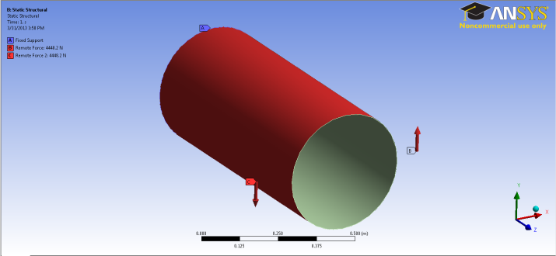

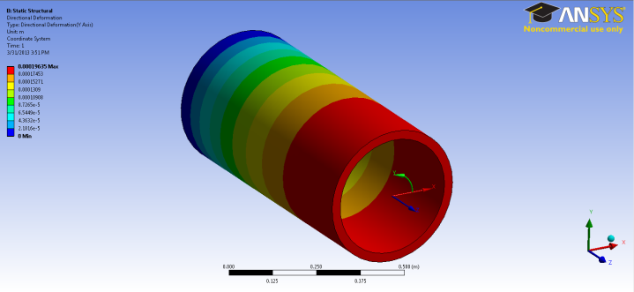

Figure 33: Setup for ANSYS Simulation

The following groups of ply sequences are simulated in ANSYS to see how their stacking sequences and ply orientations affect the torsional stiffness. The simulated laminates are shown in Table 5.

Table 5: Laminate with different stacking sequence and orientation for simulation (all laminates are symmetrical and balanced about the core)



Notice that laminate 2 is a sequence variation of laminate 1, and laminate 6 is a sequence variation of laminate 5. The purpose of these sequence variations is to detect any possible effect of stacking order on the final torsional stiffness. All the other laminate sets are there to show the impact of more 45º plies. The analytical result of each laminate is compared with ANSYS simulation, and the torsional stiffness of each is shown in Figure 34.

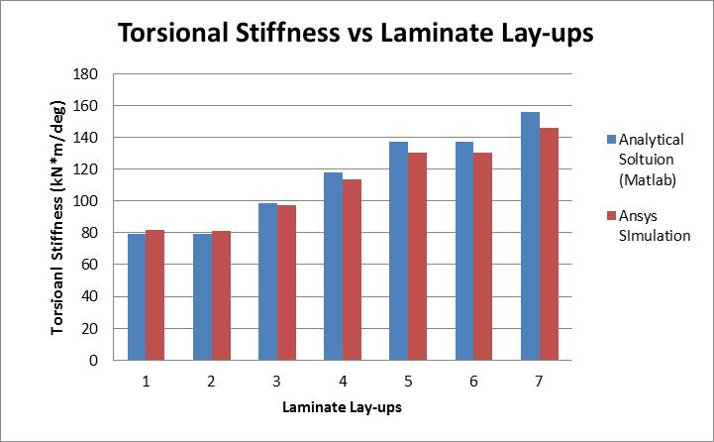

Figure 34: Torsional stiffness of different laminate sets calculated analytically and using ANSYS simulation

The deviation between the analytical solution and the ANSYS simulation is no more than 7.0%, and the graph shows that both methods agree with the interpretations from the governing equations. Indeed, stacking sequence has minimal effect on the torsion stiffness, as laminate 2 and 6 shows no changes in torsional stiffness with the laminate 1 and 5. The experiment demonstrates that more 45º plies improves the shear modulus and therefore improves the torsional stiffness. With each set of 0º plies switched into 45º plies, a torsional stiffness improves by about 15%, and the variation is linear.

After determining the best ply sequence and orientations, plies are removed to see how much weight can be reduced while maintaining the same torsional stiffness. The same experiment as above is used to remove a set of two plies from the top and bottom of the best laminate stacking sequence, which is the laminate with all 45º plies, each time. The plies are reduced until the torsional stiffness drops below the original value (baseline), which is about 81.6 kNm/deg. The ply reduction process is shown in Table 6.

Table 6: Laminate sets used for simulation to illustrate possible weight reduction (all laminates are symmetrical and balanced about the core)



The torsional stiffnesses of the laminates from Table 6 are compared with the baseline in Figure 35, and the weight reduction is shown in Figure 36.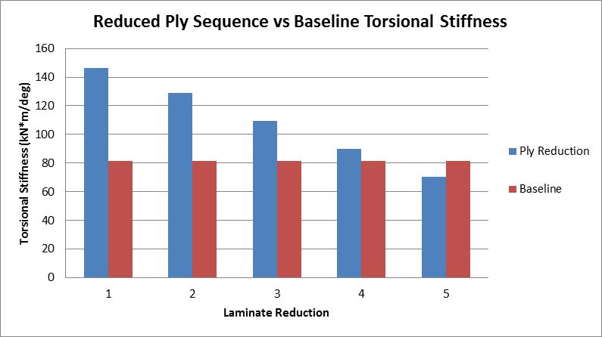

Figure 35: Torsional stiffness with reduced plies

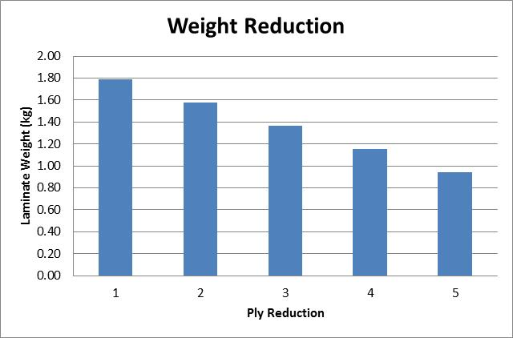

Figure 36: Possible weight reduction

The Graphs show that laminate 4 is the optimum solution because it gives the most weight reduction, 35%, while still maintaining a torsional stiffness, 90.1 kNm/deg, above the base line value.

*Increase the Core Thickness*

The other method to improve the torsional stiffness is to improve the polar moment of inertia (J). The equation to calculate J for solid cylinders is:

|  |  |
| --- | --- |
| $$J=\frac{π*({OR}^{4}-{IR}^{4})}{2}$$ J= Polar moment of inertia  OR=Outer radius  IR=Inner radius | (16) |

The ideal analytical solution to improve J is to increase OR or decrease IR infinitely, but these geometric parameters are often constrained due to other design requirements such as weight or practicality (such as monocoque external or internal size). In a real life application, a possible way to try this without adding significant weight is to increase the thickness of honeycomb core which may have a small effect due to torsion-bending coupling. To see how much the torsional stiffness improves, a simulation is setup on ANSYS for 12.7mm, 19.05mm and 25.4 mm core thickness, and the results are shown in Figure 37.

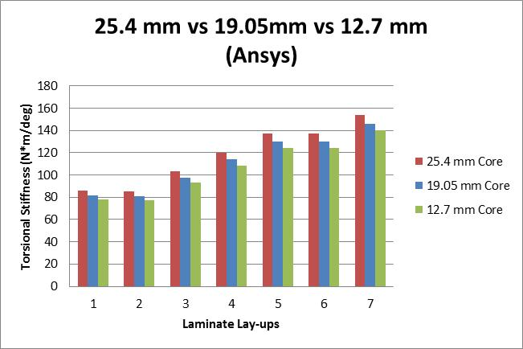

Figure 37: Torsional stiffness with increase core thickness

Figure 37 confirms the claim that increasing core thickness improves the torsional stiffness but the improvements are very small. The largest improvement for any laminate design from one core thickness to another is no more than 5.5%. If the optimum laminate design from the ply order and ply orientation optimization in previous section is boosted with 25.4 mm core, the torsional stiffness is improve to 94.4 kNm/deg. However, after removing a set of plies, the resulting torsional stiffness reduces to 73.5 kNm/deg, which is below the baseline value, 81.6 kNm/deg.

This quick simulation demonstrates that increase core thickness by 6.35mm is not enough to overcome torsional stiffness provided by one set of 45º T300 plies. Thus, as expected, core thickness is not significant in near pure torsion cases.

*Bending optimization*

Unlike typical isotropic materials, the weakest link in a sandwich structure is often its core. Our testing at Cornell found that the first ply failure for the representative sandwich structures used in our monocoques was never reached before the aluminum core failed. (Of course the failure mode would be different if the ply strength were reduced enough, if core-ply bonding were inadequate, etc.) It was also noticed that core failure generally occurs around a critical displacement; therefore optimizing a panel to minimize deflection is important to its performance under bending. Following this idea, the bending optimization method begins with the governing equation for three-point bending of a beam (equation 17).

|  |  |
| --- | --- |
| $$δ=\frac{FL^{3}}{48EI}$$ δ = the deflection of the beam  F = [force](http://en.wikipedia.org/wiki/Force) acting on the center of the beam  L = length of the beam between the supports  E = [modulus of elasticity](http://en.wikipedia.org/wiki/Modulus_of_elasticity)  I = [area moment of inertia](http://en.wikipedia.org/wiki/Area_moment_of_inertia) | (17) |

Closer examine of the equation reveals that modulus of elasticity, E and area moment of inertia, I are two important and adjustable variables for the final bending displacement, and the bigger the E and I values, the smaller the final displacement will be.

*Ply-Order & Ply-Orientation*

When composite materials are in bending, the modulus of elasticity is the flexural modulus instead of Young’s modulus. [12] This is because composite materials are anisotropic. Even though the woven fabrics we used at Cornell University were close to planar-isotropic, the properties in different directions are still different, especially in the out-of-plane direction. Because of the directional variability, the properties of a composite material, for example flexural modulus, are highly depending on the ply-stacking sequence and the ply orientations. According to Classical Laminate Theory, the effective laminate flexural moduli may be expressed in terms of the flexural compliances [12]. For the symmetric laminate subjected to bending only, the laminate moment and curvature are related by the laminate-bending stiffness, [D]matrix (equation 19), as shown in equation 18.

|  |  |
| --- | --- |
|  | (18) |
| $$D_{ij}=\frac{1}{3}\sum_{k=1}^{N}{{\left({\overline{Q}}_{ij}\right)}_{k}(z_{k}^{3}-z_{k-1}^{3})}$$ | (19) |
| $D_{ij}$ = Components of the Laminate bending stiffness matrix  M= Moments  κ = Curvatures ${\overline{Q}}_{ij}$ = Components of the transformed lamina stiffness matrix  z= Distance from the neutral surface |  |

After deriving this equation, equation 20 reveals that flexural modulus is related to the laminate bending compliance ${ D}_{11}^{'}$. [12]

|  |  |
| --- | --- |
| $$E_{fx}=\frac{12}{{t^{3}D}_{11}^{'}}$$ | (20) |
| $E_{fx}$ = Laminate flexural modulus $D_{ij}^{'}$ = Components of the laminate bending compliance matrix  t = Laminate thickness |  |

It is important to note these equations assume that mid-plane extension under bending or twisting will not occur since the coupling matrix, B matrix = 0. [12] This assumption, once again, may not appropriate when a part is under complex deformation due to coupling, but it is a good theoretical illustration of how composite stacking sequence and ply orientation effect the deformation of the plate when bending force is dominant.

To maximize, D11 value also needs to be maximized. From equation 8, one can infer that D11 can be maximized by placing the stronger plies to the outer surface of the plate. That is because the z value, which corresponding to the distance away from plane of symmetry, is raised to the third power. This means that the impact of the ply grows cubically as that ply moves further away from the center of reference. Therefore, the placement of the stronger plies in the stacking sequence will dictate the majority of the overall bending property of the laminate. Another way to optimize D11 is to increase the material property of each ply, mainly the modulus in the fiber direction. 0º plies are typically the best in that situation. Their impact is affected by their stacking sequences and is the highest when placed further away from the middle.

From a physical perspective, this method makes sense since the bending stresses are the largest on the outer layers. If a beam or a plate is optimized to perform in bending, more and stronger material should be placed on the outside to improve its strength, like an I-beam.

To utilize these optimization concepts, a simple pure bending simulation is set up according to the FSAE rules on the bending of the side impact zone of the monocoque. Dimensional specification is strictly enforced under Rule B3.28. [10] The ply stacking sequences for the simulations are listed in Table 9.

Table 9: Laminate sets with different stacking sequence (all laminates are symmetrical and balanced about the core)



The 0º plies are first moved to the outside from laminate 1 to 2, and then sets of 45º plies are switched to 0º plies in laminate 3, 4 and 5. We realize that laminate 5 using all 0º plies is not a satisfactory practical solution because in an impact the unidirectional fibers would separate and the structure would undergo catastrophic failure. We include this case show the idealized limiting behavior, which will be seen to not be much better than more practical cases.

The idea is to first identify the impact of stacking sequences on the flexural modulus, and then see how ply orientation affects the flexural modulus. A calculation was first carried out on the original stacking sequence to check the flexural modulus against physical testing data from Cornell FSAE team using the test method given in the FSAE rules. [10] After comparing the result with the physical test, the flexural modulus calculated using equation (18), (19), and (20), 46.1 GPa, was slightly underestimated compared to the physical test, 54.2 GPa.

The next adjustment is the requirement of flexural rigidity from the FSAE rule guide. According to rule B3.31.1, the side impact area must have equivalent flexural rigidity (EI) equal to the sum of the EI of the three baseline steel tubes that it replaces. [10] Since EI is a more difficult requirement to satisfy, optimization is adjusted to maximize EI instead of E. Figure 38 shows how the flexural rigidity varies with different laminates, and each flexural rigidity value is compared with the flexural rigidity of baseline steel tubes.

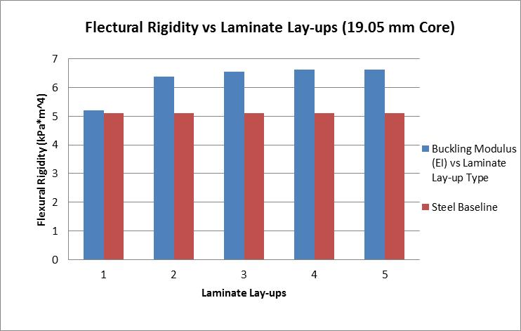

Figure 38: Flexural rigidity of each laminate set is compared with the EI of the baseline tube

The graph shows a large leap, 22% improvement, in flexural rigidity by moving the stronger plies, 0º layers, to the outside from laminate 1 to 2, but the improvements from changing the ply orientations are relatively small. In fact, the benefit of using all zeroº plies in the limiting case laminate 5 is only 5.0% higher than the bulk modulus of laminate 2. This confirms the interpretation from the analytical equation that stacking sequence has more impact on the overall bending property than the material properties gained from ply orientations. Thus, laminate 5 with all 0º plies is the best stacking sequence for absolutely pure bending even if not practical for a practical structure.

We now factor in the weight of the laminate using laminate 5 by reducing one set of plies from the top and bottom surface each time. A quick computational experiment is setup to see how many plies can be removed in the idea pure bending case. The stacking sequences in Table 10 are simulated using ANSYS, and their flexural rigidities compared with the flexural rigidity of baseline steel tubes in Figure 39.

Table 10: Laminate sets with reduced plies (all laminates are symmetrical and balanced about the core)



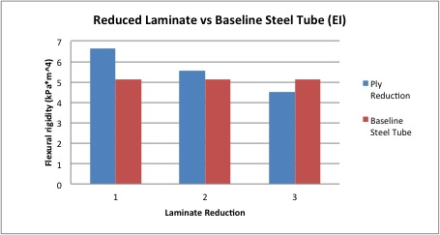

Figure 39: Flexural rigidity of reduced laminate comparing to the baseline steel tube

It turns out only one set of plies can be removed while still maintaining the acceptable flexural modulus. The weight of the panel went from .533 kg to .470 kg, and a weight saving of 12% is achieved while still satisfying all the bending requirements. It should be noted that for a practical case with non-pure-bending loadings almost the same effect could probably be achieved using stacking sequences 2 or 3, which would preserve more nearly isotropic laminate property for other types of loadings.

*Increase the Core Thickness*

The other method to improve the laminate property under bending is to improve the area moment of inertia, I. The most effective way to do that is the increase the core thickness. This is because the thickness is raised to the third power as shown in equation 10, and I will grow cubically as the thickness increases. It is important to note that core material is mostly ignored in this simulation, since it is so weak compared to the carbon fibers. The only place where the core has an effect is spacing out the plies to improve I. The equation for calculating the I for a sandwich panel is:

|  |  |
| --- | --- |
| $$I=\frac{w*(h^{3}-t^{3})}{12}$$ J= Moment of inertia  w= width  h= height $$t=thickness$$ | (21) |

A simulation is setup with 25.4 mm core to show how core increase improves the flexural rigidity and flexural rigidity of the laminates. Figure 40 shows the same laminate stacking sequence with both 25.4 mm and 19.05 mm core.

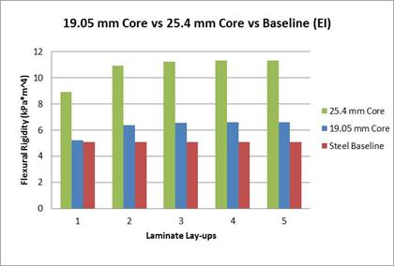

Figure 40: Flexural rigidity with 19.05mm core and 25.4 mm core

The result confirms the initial prediction as 25.4 mm core dramatically increased the flexural modulus. This provides many opportunities to save weight on such a panel. (However, in our example design we were constrained to no more than 25.4 mm core by the available mold and the interior space for the driver.) Therefore same weight reduction simulation is setup using 25.4 mm core and ANSYS to remove a set of two plies from the top and bottom surface of the best laminate stacking sequence, which is the set with all 0º s, each time. The plies are reduced until the flexural rigidity drops below the flexural rigidity of the baseline tube, which is 5.11 kPa m4. Ply sequences from Table 11 are simulated using the previous ANSYS setup.

Table 11: 25.4 mm core Laminate sets with reduced plies (all laminates are symmetrical and balanced about the core)



Figure 41 shows the flexural rigidity of reduced laminates from Table 11, and the weight reduction is illustrated in Figure 42.

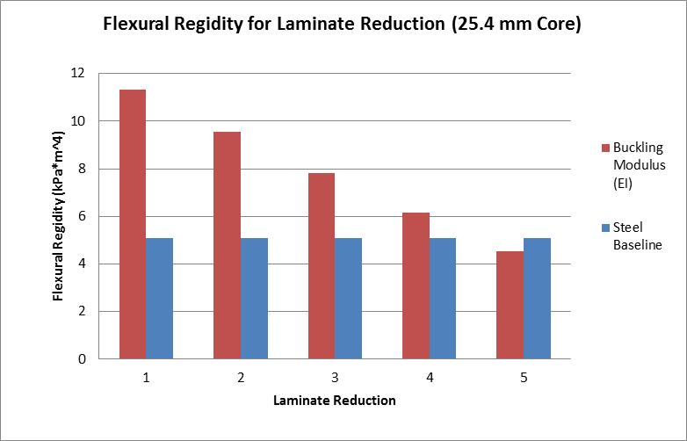

Figure 41: Flexural rigidity of 25.4 mm core laminate sets while reducing the number of plies

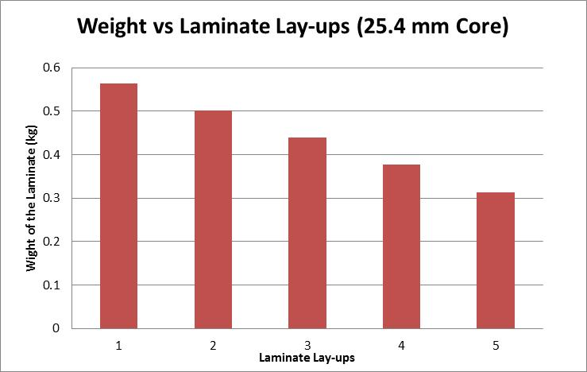

Figure 42: Weight of 25.4 mm core laminate sets while reducing the number of plies

With 25.4 mm core, the best option is laminate set 4 because it gives the largest weight reduction, 30% while still have a flexural rigidity above the baseline.

Another thing worth noting is the fact that sequence 2 shows a weight reduction with increased core thickness and decreased ply layers. This is because the density of the 5250 aluminum core, 49.5 kg/m3, is much smaller than density of the T300 weave, 1450 kg/m3; therefore reducing one set of T300 plies can overcome the weight increase from the increased core thickness without losing much bending strength.

*Mixed Loading Conditions*

In the boundaries where bending and torsion are equally important, good engineering judgment must be applied to determine the optimum number of 0º and 45º plies as well as their sequences. However, before that, it is clear that increasing the core thickness can improve the properties in both bending and torsion. Since the density of the core is small comparing to the density of the carbon fiber, it is always a good weight reduction method to decrease the amount of plies with core thickness increase. The thing to keep in mind is that the magnitude of improvement in bending and torsion are different as observed in the previous computational experiments. Torsional improvements from core thickness increase are not very important because the magnitude of increase is significantly smaller than the increase in bending. Caution must be taken when reducing plies, so torsional stiffness does not decrease below the target value, which in this paper’s example design was about 5000 Nm/deg, based on the considerations discussed in the Chassis Stiffness Targets section of the paper.

Once the core thickness is solidified, the difficult part of the optimization is to identify the ply order and ply orientations. The strength of the 0º and 45º are exactly opposite of each other in bending and torsion. In our example case, the bending requirements for some of the panels are set by FSAE safety ruled while our torsional stiffness goal is set by suspension requirements. Because torsional and bending properties can conflict with each other in mixed loading conditions, adjustment must be done systematically so both properties are improved instead of one or the other.

*Ply-Order & Ply-Orientation*

Recalling the computational experiment results from Figure 38, the improvement in bending was significant by moving the 0 degree plies to the outside. This is shown from the big flexural rigidity leap from laminate 1 to laminate 2. After that, the improvement was not significant from adjusting ply orientations. In fact, the improvement from all 0º plies, laminates 5, and was only 5% from the laminate 2. This brings up an interesting point, how many 0º on or near the outside is enough to obtain the majority of bending properties.

A computational experiment is setup using the same side impact panel with the following laminate sequences (Table 13), and the EI of each laminate set is compared in Figure 43.

Table 13: Laminate set experimented to evaluate the effect of exterior 0 º plies on the overall bending property (all laminates are symmetrical and balanced about the core)

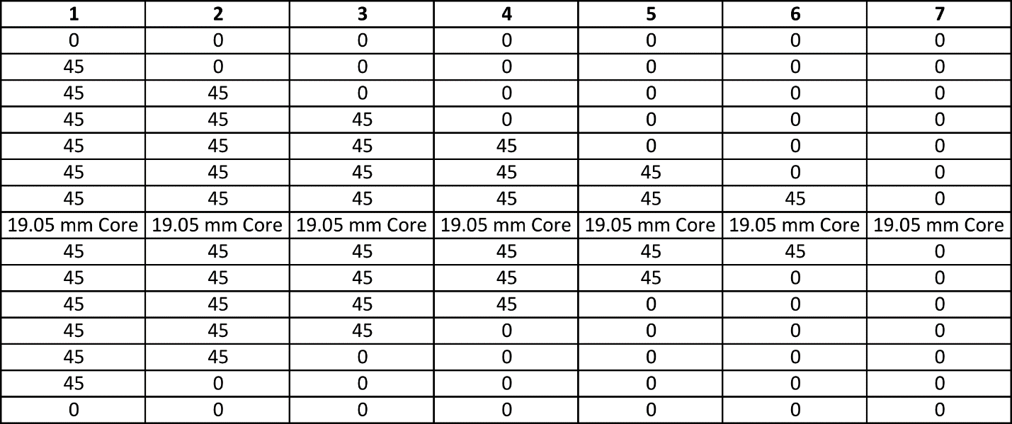

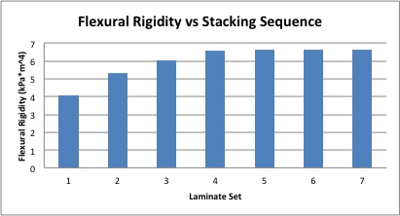

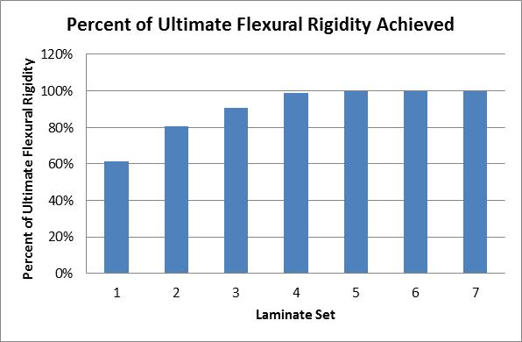

Figure 43: EI of the different exterior 0 º plies laminate set and their percentage comparing to the best EI property

The graph clearly demonstrates that the majority of the laminate property in bending is obtained with a few 0º plies on the outside. In fact, only three sets of 0º are needed to achieve 90 % of the ultimate EI. It was also noticed that the influence of outer 0º plies on the overall property increases as the number of total ply decreases. This idea is demonstrated when a different panel with less plies is used for a similar experiment. The laminate sequences are shown in Table 14 and the result is compared in Figure 44.

Table 14: Reduced laminate set experiment to evaluate the effect of exterior 0 º plies on the overall bending property (all laminates are symmetrical and balanced about the core)



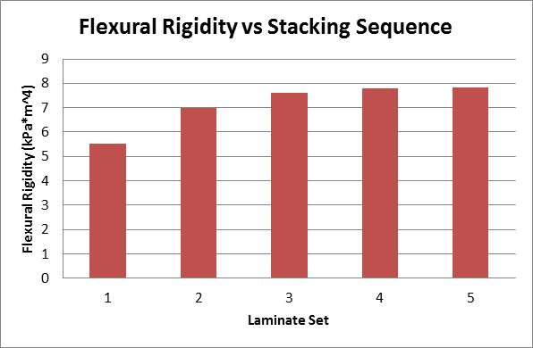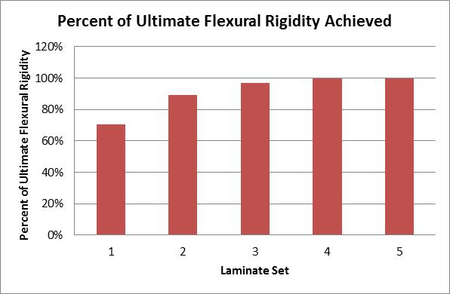Figure 44: EI of the reduced laminate sets and their percentage comparing to the best EI property

90% EI is achieved with only two sets of 0º plies on the outside. This is because of the triangular shape of the stress distribution in a beam or a plate while experiencing pure bending (Figure 45). If proportion of the 0º plies thickness to the overall laminate thick increases, then it will take on more areas of the stress distribution, 0º plies on the outside have more impact on the overall bending properties with laminate made of fewer plies.

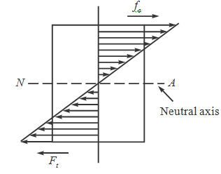

Figure 45: Stress distribution of a beam or plate in bending

Therefore, in situations where bending and torsion are both important, optimization for torsional property should be done first to figure out minimum number of 45º plies is needed to achieve a certain torsional stiffness requirement, and then adding 0º plies to the outside until the bending requirement are satisfied. The reason behind this optimization sequence is because torsional properties are dependent on less independent variables, which means less room and fewer options are available to improve the target value. On the other hand, bending properties are dependent on more independent variables, even if optimizing for torsional properties limits the options to adjust certain variables, other variables can still be adjust to improve the bending properties. This will be an iterative process as the designer goes back and forth between the bending and torsional properties until the plies cannot be reduced further.

To better illustrate this optimization process, an example is presented on optimizing the side impact panel for a mixed loading condition. Table 15 shows the T300 weave laminate lay-ups of each steps of the optimization process. The change in torsional stiffness and flexural rigidities compared with the base line in Figures 46 and 47.

Table 15: T300 weave Laminate lay-up for each step of the optimization process



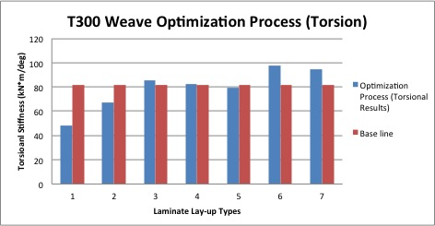Figure 46: T300 Weave torsional stiffness change comparing to the design baseline during the optimization process

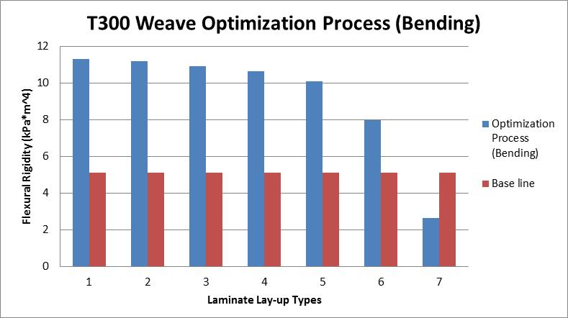Figure 47: T300 Weave flexural rigidity change comparing to the design baseline during the optimization process

One can notices that the optimization process jump between torsion and bending in step 3, 5 and 7. Once the torsional stiffness drops below the target value from reducing 0º plies, a 45º is added to increase the torsional stiffness back above the baseline. Typically, the process is done when bending property drops below the target value. From this optimization, the final laminate lay-up is compared with the original in Table 16.

Table 16: Side Impact Panel original and optimized laminate design (all laminates are symmetrical and balanced about the core)



Both laminates have similar bending and torsional strength, but the optimized laminate design shows an 18 percent weight reduction with four layers of plies removed. The optimized laminate is applied in the ANSYS simulation and the results are explained in the latter section.

*Applying the Method*

To apply this method, a simulation model (Figure 48) is built using ANSYS Composite PrepPost with the same setup as the 2013 FSAE race car at Cornell University. The back suspension points are constraint while a force of 4.45 kN is applied to each side of the front suspension with opposite magnitude. The torsional stiffness is simulated to be 4.57 kNm/deg.

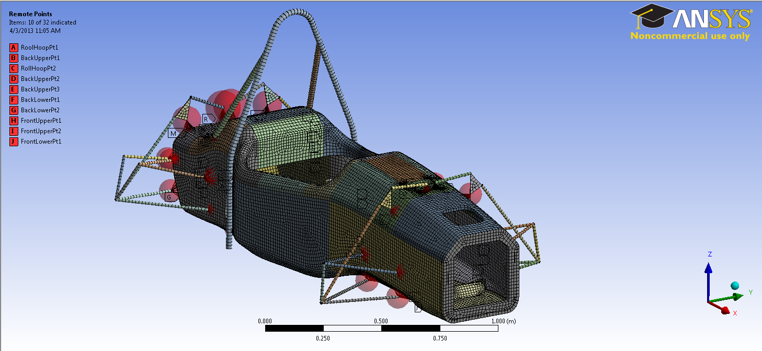

Figure 48: ANSYS model of the composite monocoque chassis

This method is applied to three different panels on the car: side impact, front hoop bracing, and front bulkhead support. Their critical loading cases are shown in Table 18.

Table 18: Loading case of the three panels tested

|  |  |  |  |
| --- | --- | --- | --- |
| **Panel Name** | **Bending** | **Torsion** | **Mixed** |
| Side Impact |  |  | X |
| Front Hoop Bracing |  | X |  |
| Front Bulkhead Support |  |  | X |

According to their specific loading cases, the optimum stacking sequence (Table 19) for each panel is determined using the optimization methods explained previously and their bending and torsional properties are compared with the original panel in Table 20.

Table 19: The original and optimized laminate stack-ups (all laminates are symmetrical and balanced about the core)



Table 20: Bending and torsional properties of the three panels before and after optimization





The simulation result concurs with analytical prediction as the new overall torsional stiffness turn out to be 4.92 kNm/deg. 7.7% improvement. The improvement from each panel and the overall improvement in torsional stiffness are compared with the original value in Table 21. The only weight increase is from the increased core thickness from 19.05 mm to 25.4 mm, which is not very much compared to the weight of the composite.

Table 21: Improvement in overall torsional stiffness from the laminate adjustments



Once the torsional stiffness is improved, plies are removed from each panel while still maintain the baseline torsional stiffness and bending requirement. Table 22 gives the reduced ply orders for the same three panels. Their bending and torsional properties are compared with their original stacking sequence in Table 23.

Table 22: Reduce laminate stack-ups (all laminates are symmetrical and balanced about the core)



Table 23: Bending and torsional properties comparison from the reduced panel to the original





The torsional stiffness is 45.2 kNm/deg, which is slightly lower than original, about 1 percent, but the analytic method was correct again in predicting that these plies would have about the same torsional stiffness as the original. Along with that, four plies are saved from the side impact and front bulkhead support panel, and two plies are reduced from the front hoop bracing section which according to ANSYS is a 6.4% overall weight reduction.

This anisotropic optimization method should provide a systematic direction for a monocoque designer to obtain the desired torsional stiffness with minimal weight while still satisfying all the competition requirements. It should also provide a general idea of the performance expectation from modifying different anisotropic variables to customize in different situations.

FATIGUE ANALYSIS

A monocoque race car chassis experiences cyclic loadings during its lifetime from the engine vibration and drive torque forces and from the suspension loads from driving. Of course a structure must be designed to be sufficiently strong for the maximum loads expected using conventional measures such as von Mises yield or Tsai-Wu failure. However, repeated, smaller cyclic loads can also cause fatigue failures in conventional or composite materials. A number of FSAE teams have reportedly experienced fatigue failures of engine mounts or suspension hardpoints in composite structures. Thus we present here a few of the considerations for designing a composite structure for adequate fatigue life. At Cornell we have not yet completed enough fatigue tests to apply these considerations to our car; to date we have successfully depended on conservative designs.

We consider a monocoque that is built with composite sandwich structures. The anisotropy of sandwich structures means that, in composite structural design, a stress tensor can result in a relatively small strain in the fiber direction while causing relatively larger strains in other directions. Then if the strain or repeated strain is high enough, failure can occur in the other directions. Good introductions to composite fatigue failure can be found in several references. [13][14][15] A composite structure has many possible failure modes, including fiber breaking, matrix cracking, transverse ply cracking, delamination, core failures, and debonding of fibers or between plies and core and. However, many composite designs that are likely to suffer miscellaneous impacts have the face sheets overdesigned either for adequate stiffness or to be able to withstand occasional impacts without damaging the face sheets or the core.

Our experiences, based on observations of some other teams failures and of all our tests on samples representative of the monocoque panels used at Cornell, have shown that the failures have been dependent on the failure of the core (aluminum honeycomb), rather than the failure of the carbon composite face sheets (T300 weave carbon fiber in our case). Of course, this depends on the relative strengths and stiffnesses of the core and carbon faces and their bonding in any particular design. We probably overdesign our face sheets by seeking durability in cases of minor impacts as mentioned above.

In order to analyze the fatigue strength of any structure we need to identify the major variable loading sources. The major varying loads on a race car chassis come from two sources: from the vibration and drive torque reactions of the engine, etc. and via the suspension from accelerating, braking, cornering, and random bump loads. The specific areas that bear those loads are the hardpoints or inserts of the engine mounts and the suspension mounts.

Thus the fatigue lifetime of the monocoque should be determined based on its required lifetime and on the loads and frequency and magnitude of the engine as well as the suspension loadings. For the Cornell FSAE race car, Table 24 shows the calculation of lifetime and cycles for the engine that would need to be considered in the fatigue analysis.

Table 24: The calculation of lifetime and loading cycles of engine for fatigue analysis



For this particular case, a physical experiment would have to be carried out to verify if a sample of the engine attachment experiences any fatigue failure within $2.688×{10}^{8}$ cycles. One would have to check for failure in the aluminum core, layers of carbon fiber or bonding.

A similar calculation can be carried out for the suspension loadings based on load cell measurement of loads in our suspension push links and the resultant loads in other links. The specific areas that bear those loads are the hardpoints or inserts of the engine mounts and the suspension mounts. Figure 49 shows the structure of the front suspension system with suspension hardpoints identified.

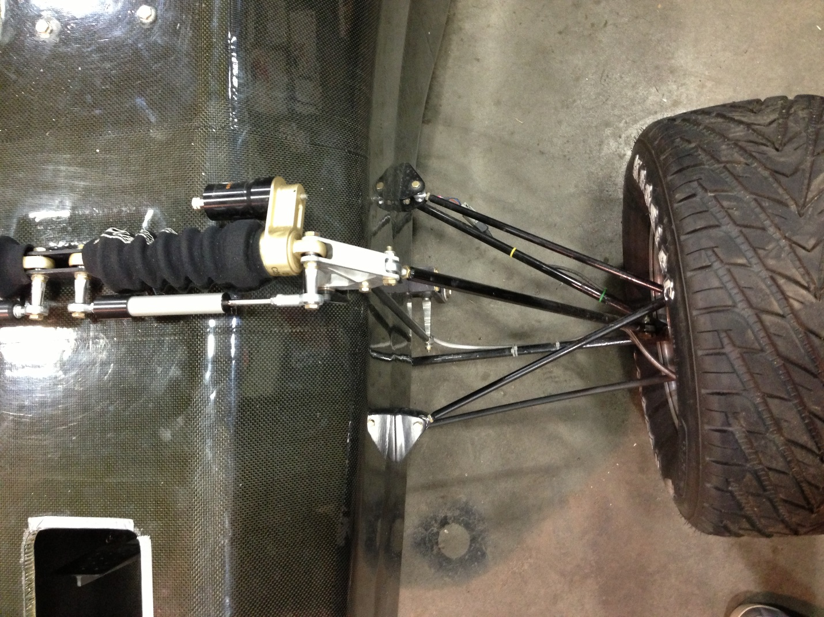

Figure 49: Front suspension including the damper

Even though the damper and spring mounts in the picture carry the vertical loads from the track, the A-arms will transfer reaction loads to other inserts as indicated. These will apply two opposite loads to the Monocoque, especially when the car is cornering.

To analyze the fatigue of the monocoque based on the critical loads identified, S-N curves should be experimentally generated for samples of the local structure to evaluate the fatigue performance over time. Strain should be used as the vertical ordinate of the S-N curve for the following reasons:

1. It is relatively easy to measure the displacement and strain around the inserts/hardpoints by using transducers like strain gages, etc. or constant amplitude testing.
2. It is easy to get the allowable cycles based on measured strain with the design specification from an S-N curve.

Thus, to apply this, the method to determine the lifetime of the monocoque would the follow three steps:

1. Plot the S-N curve by performing enough fatigue tests on a partial model of the monocoque’s sandwich structure.
2. Put load cells or strain gages on some suspension links and/or around all important inserts (inserts for the engine mounts and suspension mounts) on both orthotropic directions, and record the strain during test drives.
3. Then, find the relative large strain value and find the allowable number of cycles on the S-N curve plotted in step one and determine a service life.

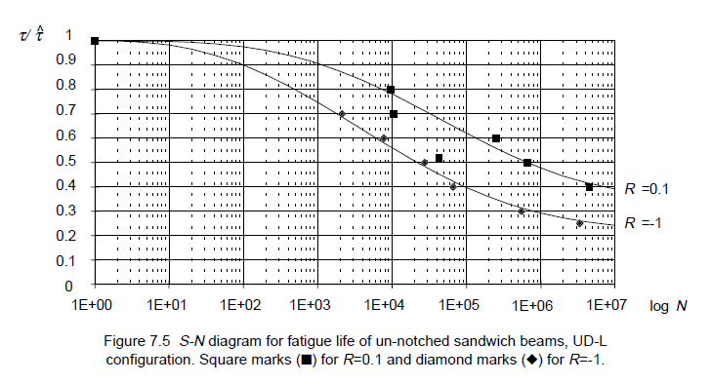

Figure 50: S-N diagram for fatigue life of un-notched sandwich with honeycomb double wall thickness along beam direction. [16] Square marks for R=0.1 and diamond marks for R=-1 and t/t^ = load/static failure load

Figure 50 shows an example of S-N curve of a sandwich structure [16]. R is the load ratio, introduced as:

|  |  |
| --- | --- |
| $$R=\frac{S_{min}}{S_{max}}$$ $S_{min}$ = Minimum strain $S_{max}$ =Maximum strain | (22) |

where R < 0 corresponds to a load cycle with both compression and tension loading or positive and negative shear. The interval 0 < R < 1 represent tests under tension/tension loads and R > 1 corresponds to compression/compression loading. For our case, we have a two opposite loading condition on the suspension inserts, so we should be using the lower curve, R =1.

If the value of cycles ‘N’ we obtain from step 3 is less than the required cycles, this means that the lifetime of current structure cannot satisfy the fatigue requirement. Therefore, under the conditions where the torsion and bending requirement are satisfied in previous design process, additional built-up plies would be needed in order to increase the ultimate strength and stiffness of the sandwich structure to increase its ability to overcome fatigue failure. By adding enough additional plies the structure will be able to stay below the endurance limit at the required number of cycles, where no fatigue failure would be experienced.

CONCLUSION

This paper has considered a variety of issues related to composite monocoque design with an emphasis on Formula SAE cars. The different overall and local loads and deformation modes are first considered in isotropic models to gain insight into proper design concepts and targets for the monocoque structure. After that, the knowledge gained from isotropic analysis is transferred to anisotropic analysis where core thickness, ply stacking order, and ply orientations are optimized to obtain required stiffness with minimal weight. The tables and charts presented can aid in visualizing the compromises between torsional, local and bending stiffness and weight the designer must make. To test the method, a full monocoque/suspension finite element model was constructed in ANSYS using the original and adjusted ply designs and the results compared between the two configurations. Finally, some fatigue analysis is presented to illustrate how to check a vehicle design under given loading for fatigue failures in the composite material.

ACKNOWLEDGEMENTS

This work is based to a substantial extent on the experience of sixteen years of Formula SAE racing car design and participation by the Cornell University teams and related research by students including Cole Wrightson, Brian Zander, Ryan Kennett, Ting-Yu Lee and Zhi Zhang. Important assistance in composite structural analysis was given by Professor Stuart L. Phoenix and in ANSYS composite simulation from Senior Lecturer Rajesh Bhaskaran and ANSYS Senior Technical Services Engineer Sean Harvey. Without the efforts of many previous team members, peers, mentors and advisors, this paper would not have been possible.

REFERENCES

1. Riley, W. and George, A., "Design, Analysis and Testing of a Formula SAE Car Chassis," SAE Technical Paper 2002-01-3300, 2002, doi:10.4271/2002-01-3300.
2. Costin, M. and Phipps, D., “Racing and Sports Car Chassis Design,” Robert Bentley, Cambridge, Massachusetts, USA, 1962
3. Deakin, A., Crolla, D., Ramirez, J. P., and Hanley, R., The Effect of Chassis Stiffness on Race Car Handling Balance, SAE Paper 2000-01-3554, SAE, Warrendale, PA, 2000.
4. Zipfel, M. and George, A., "Compliance and Friction in Elastic and Mechanical Joints of Race Car Suspensions," SAE Technical Paper 2006-01-3650, 2006, doi:10.4271/2006-01-3650.
5. Heimbs, S. and Pein, M., “Failure Behavior of Honeycomb Sandwich Corner Joints and Inserts,” Composite Structures vol. 89 (4) August, 2009. p. 575-588 Elsevier, Amsterdam, Netherlands, 2009, doi: 10.1016/j.compscitech.2007.01.027. ISSN: 0266-3538.
6. Weidner, L., Radford, D., and Fitzhorn, P., "A Multi-Shell Assembly Approach Applied to Monocoque Chassis Design," SAE Technical Paper 2002-01-3360, 2002, doi:10.4271/2002-01-3360., Also: SAE 2002 Transactions, Journal of Passenger Cars - Mechanical Systems, 2003, p.2486-2491
7. American Institute of Steel Construction, “Torsional Analysis of Structural Steel Members,” Steel Design Guide Series 9, 1997
8. Reddy, J.N., “Theory and Analysis of Elastic Plates and Shells,” CRC Press, Taylor and Francis, ISBN 9780849384158: 95-110, 2007
9. National Aeronautics and Space Administration, “A Study of Stiffness Matrices for the Analysis of Flat Plates”, Technical Note, 1968
10. 2013 Formula SAE® Rules, Revision of March 5, 2013
11. Tebby, S., Esmailzadeh, E., and Barari, E., "Methods to Determine Torsion Stiffness in an Automotive Chassis." Computer-Aided Design & Applications 1st ser. 8: 67-75, 2011, doi: 10.3722/cadaps.2011.PACE.67-75.
12. Gibson, R. F., “Principles of Composite Material Mechanics,” Taylor & Francis, Boca Raton, FL, ISBN 0-8247-5389-5:261-303, 2012.
13. Harris, B., “A Historical Review of the Fatigue Behavior of Fibre-reinforced Plastics,” Chapter 1 In Harris, B., “Fatigue in Composites”, Boca Raton, Fla.: CRC Press; Cambridge, U.K.: Woodhead, 2003.
14. Davis, A. J. and Curtis, P. T., “Fatigue in Aerospace Applications,” Chapter 22 in Harris, B., “Fatigue in Composites”, Boca Raton, Fla.: CRC Press; Cambridge, U.K.: Woodhead, 2003
15. Burman, M., “Fatigue Crack Initiation and Propagation in Sandwich Structures”, Kungliga Tekniska Hogskolan, ProQuest, UMI Dissertations Publishing, Sweden, 1998.
16. Burman, M. and Zenkert, D. “Fatigue of Undamaged and Damaged Honeycomb Sandwich Beams, Journal of Sandwich Structures and Materials 2000 2: 50. DOI: 10.1177/109963620000200103. Also see: Burman, M., “Fatigue Crack Initiation and Propagation in Sandwich Structures”, Kungliga Tekniska Hogskolan, ProQuest, UMI Dissertations Publishing, Sweden, 1998.

1. Depending on whether horizontal lozenging of section B is constrained or not, we can have a significant amount of longitudinal bending in addition to twist.